**FMPM Manual**

**FMPM** represents **F**unctional **M**ixed **P**rocesses **M**odels. The aim of this tool is to implement a functional analysis pipeline, for the joint analysis of longitudinally measured functional data and clinical data, for example age, gender and disease status. FMPM consists of a functional mixed effects model for characterizing the association of functional response with covariates of interest by incorporating complex spatial–temporal correlation structure, an efficient method for spatially smoothing varying coefficient functions, an estimation method for estimating the spatial– temporal correlation structure, a test procedure with local and global test statistics for testing hypotheses of interest associated with functional response, and a simultaneous confidence band for quantifying the uncertainty in the estimated coefficient functions.

**Motivation:** FMPM framework is motivated by the emerging demand to analyze massive functional (or imaging) data collected in large-scale longitudinal biomedical studies, such as the Alzeimer's disease neuroimaging initiative (Evans and Group, 2006). Although there is an extensive literature on statistical methods for the analysis of univariate (or multivariate) variables measured longitudinally, little has been done on the development of statistical methods to analyze longitudinal functional data. This could be due to at least three major challenges including (i) infinite dimensional functional responses measured at multiple time points, (ii) complex spatial–temporal correlation structure, and (iii) complex spatial smoothness. According to the best of our knowledge, a longitudinal functional principal component analysis in Greven et al. (2010) is the first statistical method for the analysis of repeated functional responses, in which an estimation procedure was proposed to estimate both fixed effect curves and spatial–temporal covariance operators. However, in Greven et al. (2010), there is a lack of several formal statistical inference tools, such as a test statistic. Moreover, in Geng et al. (2012), a functional mixed effects model proposed by Guo (2002) was used to analyze fiber-tract diffusion properties from longitudinal studies. However, since the functionalmixed effects model in Guo (2002)was developed to model the datawith functional responses (of time or distance) measured only once for each subject, directly applying suchmodel in Guo (2002) to functional responses measured multiple times essentially accounts for only the spatial correlations, but ignores the within-subject temporal correlations. The aim of this paper is to present a functional analysis pipeline (FMPM) with several formal statistical inference tools for delineating the dynamic changes of fiber-tract statistics and their associations with a set of covariates obtained from longitudinal studies.

**How to use FMPM**

**Hypothesis Testing**

The whole procedure for hypothesis testing can be found in HT _FMPM_Example.m. When you use the procedure, what you need to do is to

1. Prepare the data in the required format

Necessary Data and Data Format are as follows:

1) Ydesign --- response matrix;

2) Xdesign --- design matrix including intercept;

3) Zdesign --- design matrix including intercept;

4) Indicator --- $n×1$ cell, where each cell is a $r_{i}×1$ vector, containing the indices for

each subject *i*;

5) arclength --- $L_{0}×1$ column vector of the arclength from one end to the other end

where

n --- number of subjects;

$L_{0}$--- number of location of fiber tract;

$p_{x}$--- number of covariates with respect to fixed effects;

$p_{z}$--- number of covariates with respect to random effects;

$r_{i}$--- number of repeated measurements for each subject;

1. Specify the contrast matrix and the corresponding zero vector

For example, suppose there are three covariates including intercept, age and gender. If you want

to test the effect of age, you need to specify the contrast matrix and the corresponding zero

vector as follows:

Cdesign=[0,1,0];

B0vector=zeros(1,L0);

3) specify ExpVar. E.g., ExpVar=0.99;

**Simultaneous Confidence Interval**

The whole procedure for estimating the simultaneous confidence interval can be found in SB

_FMPM_Example.m. When you use the procedure, what you need to do is to

1) prepare the data in the required format, see Hypothesis Testing part.

2) specify ExpVar, see Hypothesis Testing part.

**How to use FMPM GUI**

**FMPM GUI** is a MATLAB graphical user interface software developed to do data processing.

Before using **FMPM GUI** to do data processing, you have to create a mat file containing Xdesign matrix, Ydesign matrix, Zdesign matrix, Indicator cell and arclength vector. You also need to create a mat file containing Cdesign matrix. Then put these two files into a folder which will accept outputs.

Click **FMPM** button in SSPM interface, or set **FMPM** in the SSPM package and type *FMPMgui* directly, the **FMPM** GUI occurs, as shown in Figure 1.

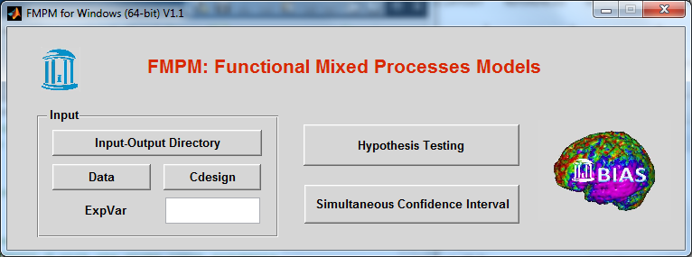

Figure 1

Click ‘Input-Output’ to choose the folder containing the mat files you created. Click ‘Data’ to choose the mat file containing Xdesign matrix, Ydesign matrix, Zdesign matrix, indicator cell and arclength vector. Click ‘Cdesign’ to choose a mat file containing Cdesign matrix. Type a number in the ‘ExpVar’ box. Click ‘Hypothesis Testing’ to do hypothesis testing’, click ‘Simultaneous Confidence Interval’ to calculate confidence intervals simultaneously. All results will be put into the ‘Input-Output’ folder.